SALESFORCE PROJECT

MILKEASE

* **Phase 2 :  Org Setup & Configuration**

👉 Goal: Prepare Salesforce environment.

* Salesforce Editions:-
* Use **Developer Edition Developer Org** (free dev org).

|  |  |
| --- | --- |
|  | **Salesforce.com Organization ID :-** 00Dfj000008eNfh   * User Name :- khushi.jain.csbs22410@agentforce.com |

* 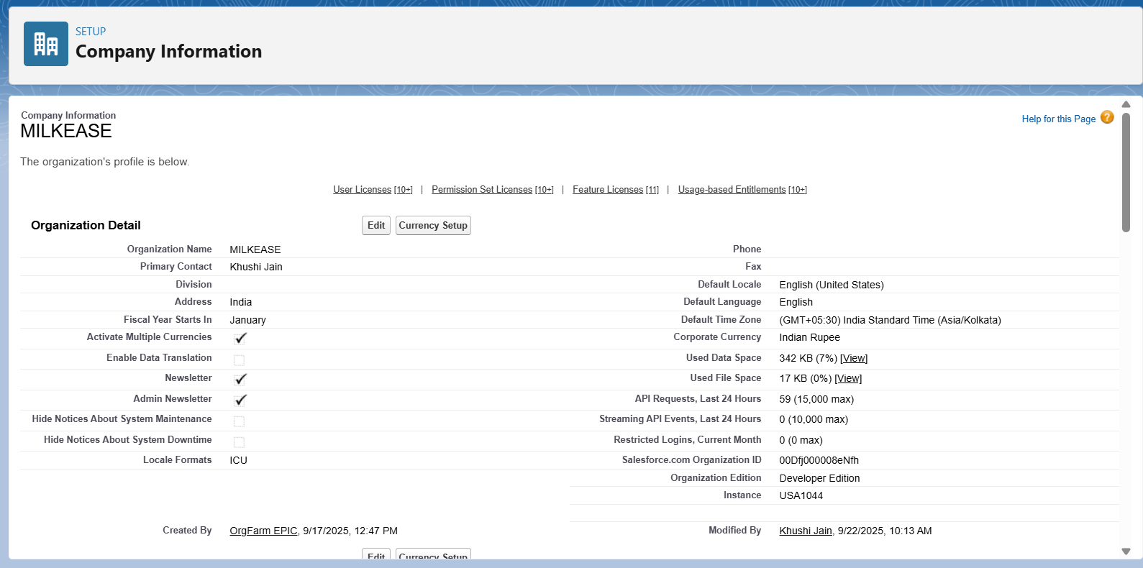Company Profile Setup:-
* Business Hours & Holidays:-
* Define working hours (6am–10pm).

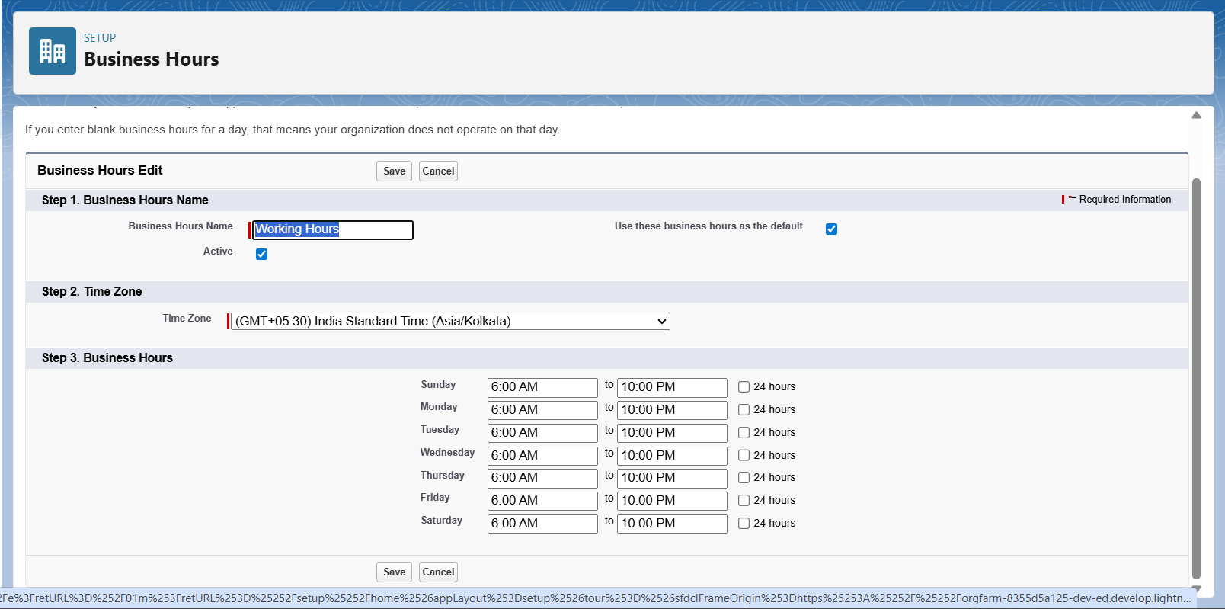

* Fiscal Year Settings:-
* Standard (Jan–Dec) → good for revenue reporting.

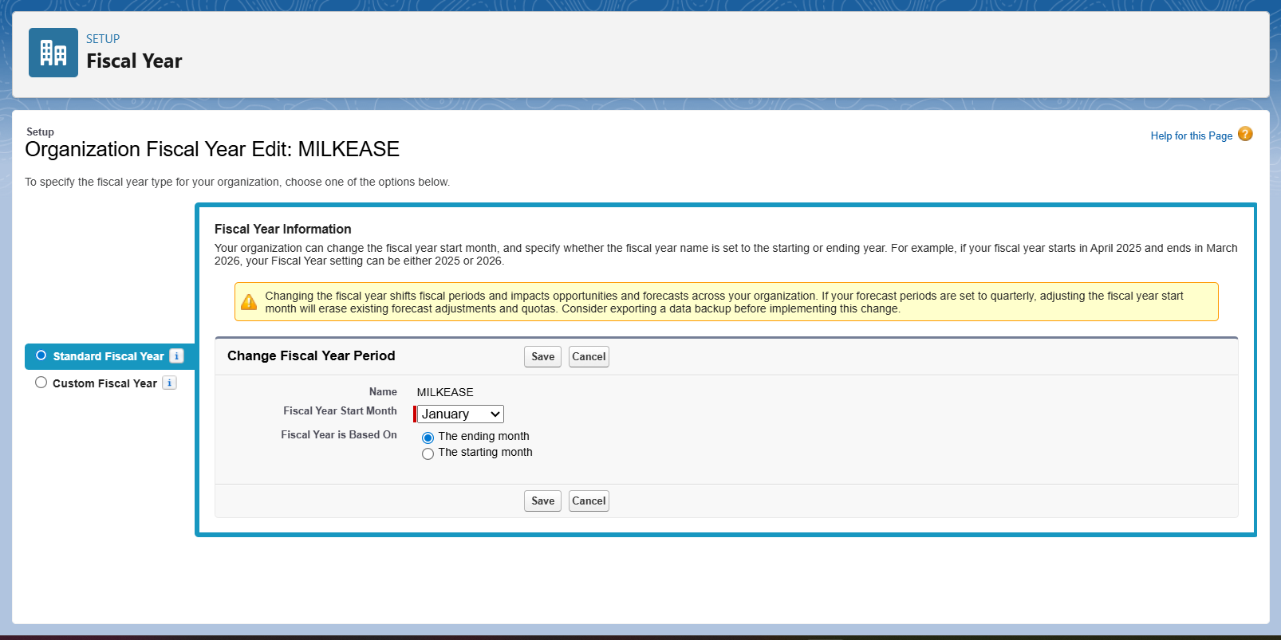

* User Setup & Licenses:-
* Delivery Agent – manages daily milk deliveries.

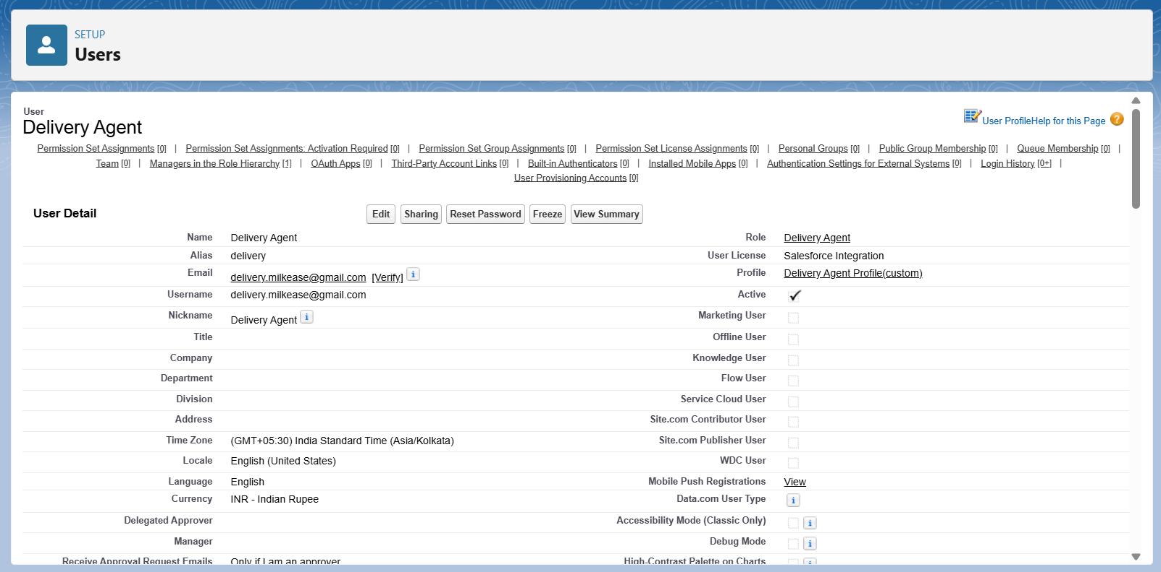

* Manager/Owner – oversees deliveries, billing, and reports.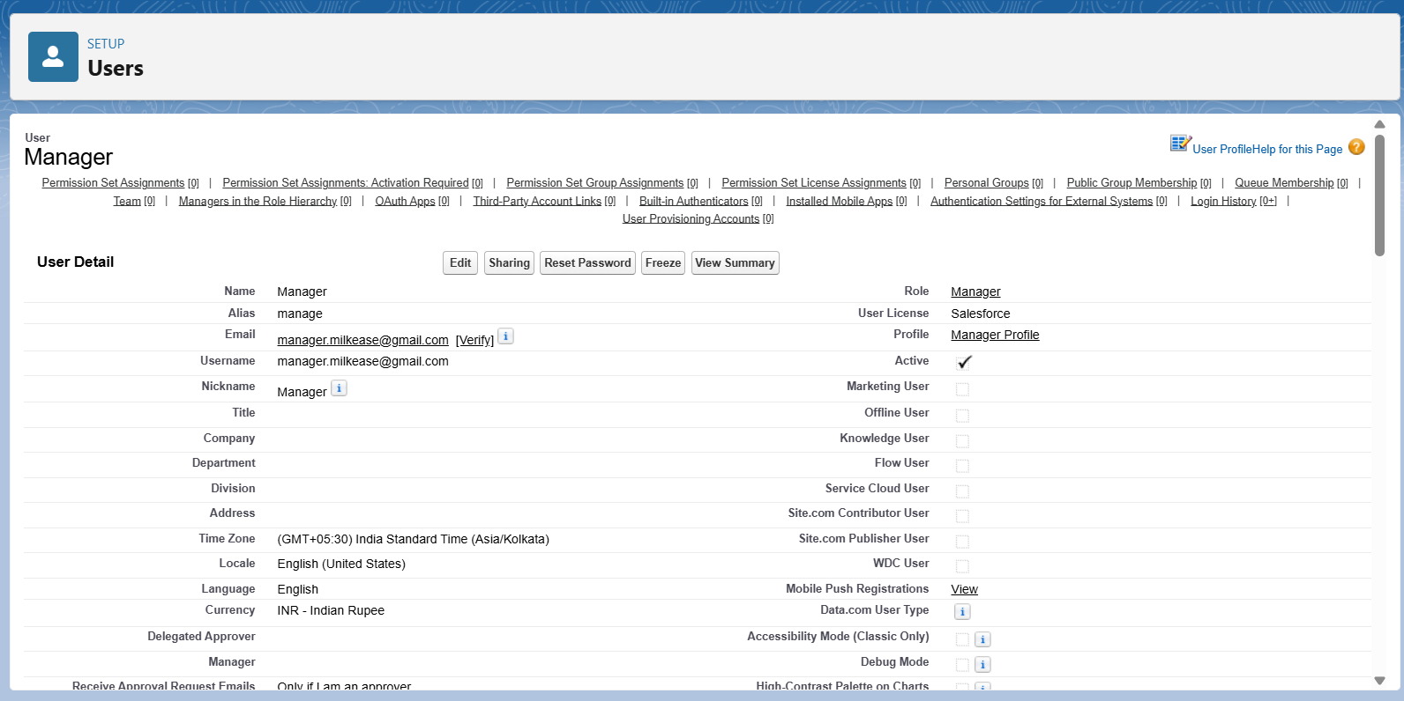
* Customer Support Executive – handles subscription changes.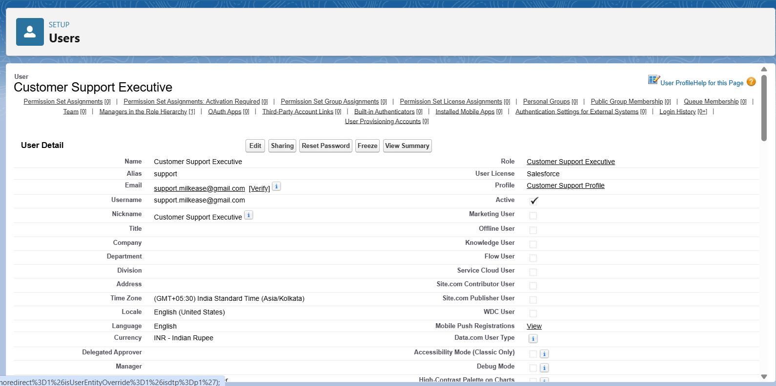
* Profiles:-
* Delivery Agent Profile :- Can update deliveries & customer subscription details.

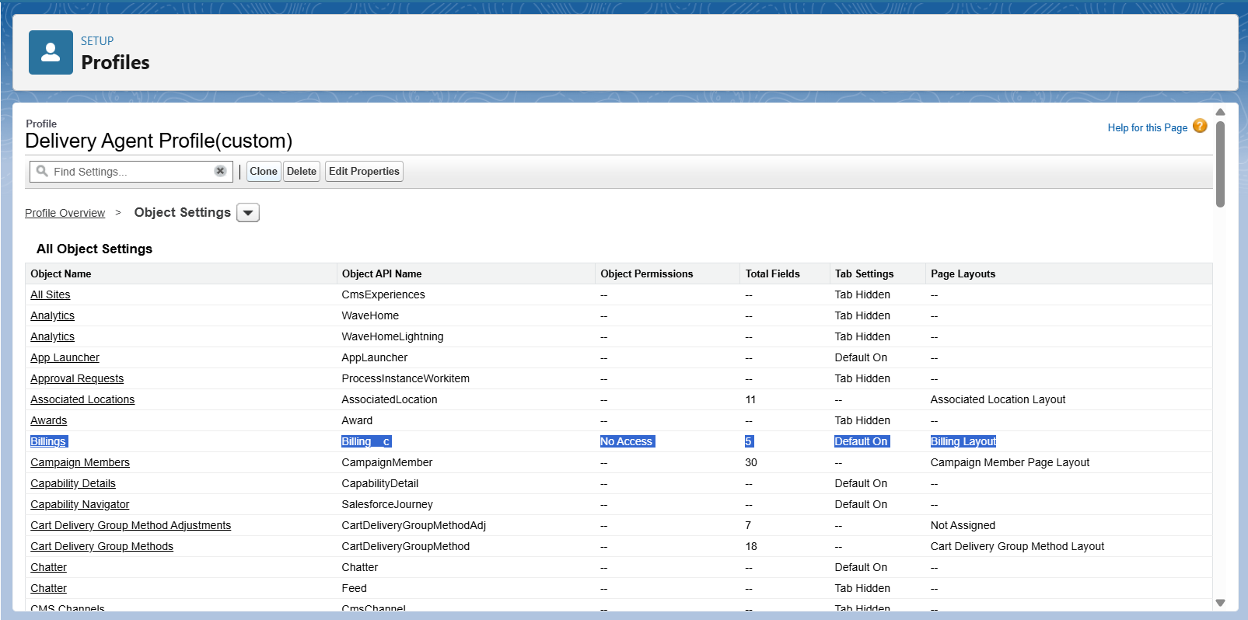

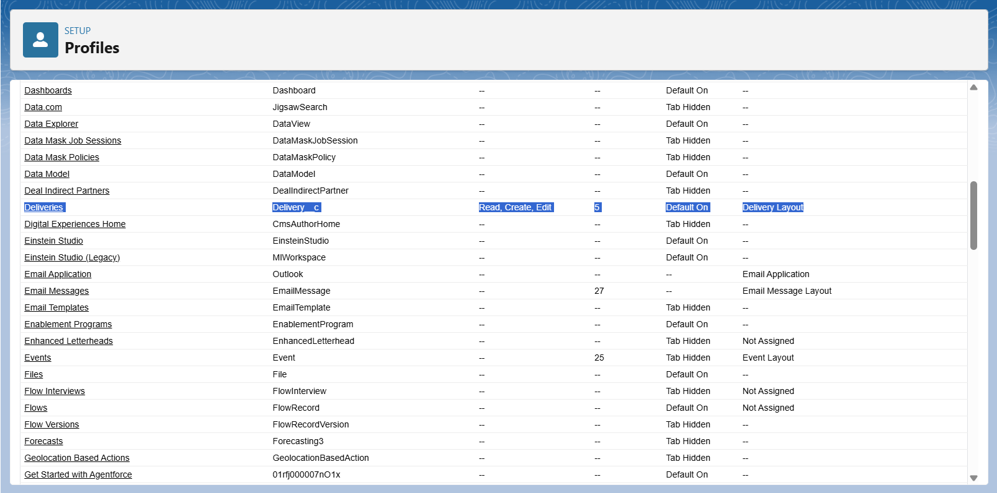

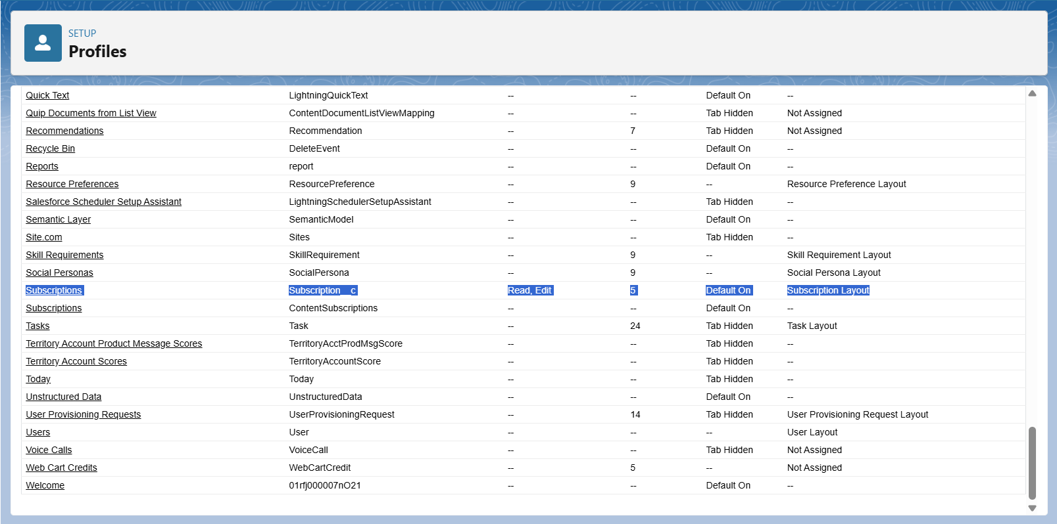

* Customer Support Profile:- Can modify subscriptions, update customer addresses/quantities.

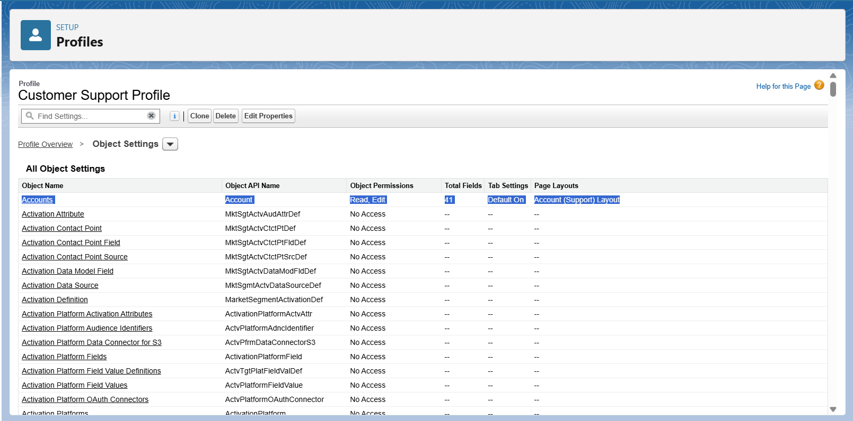

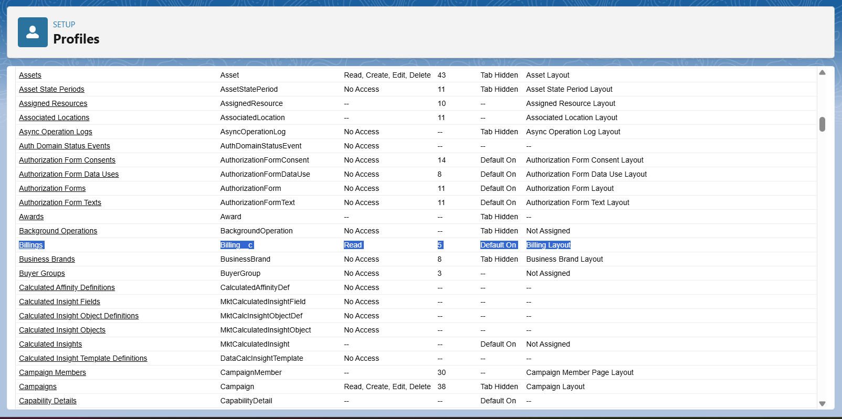

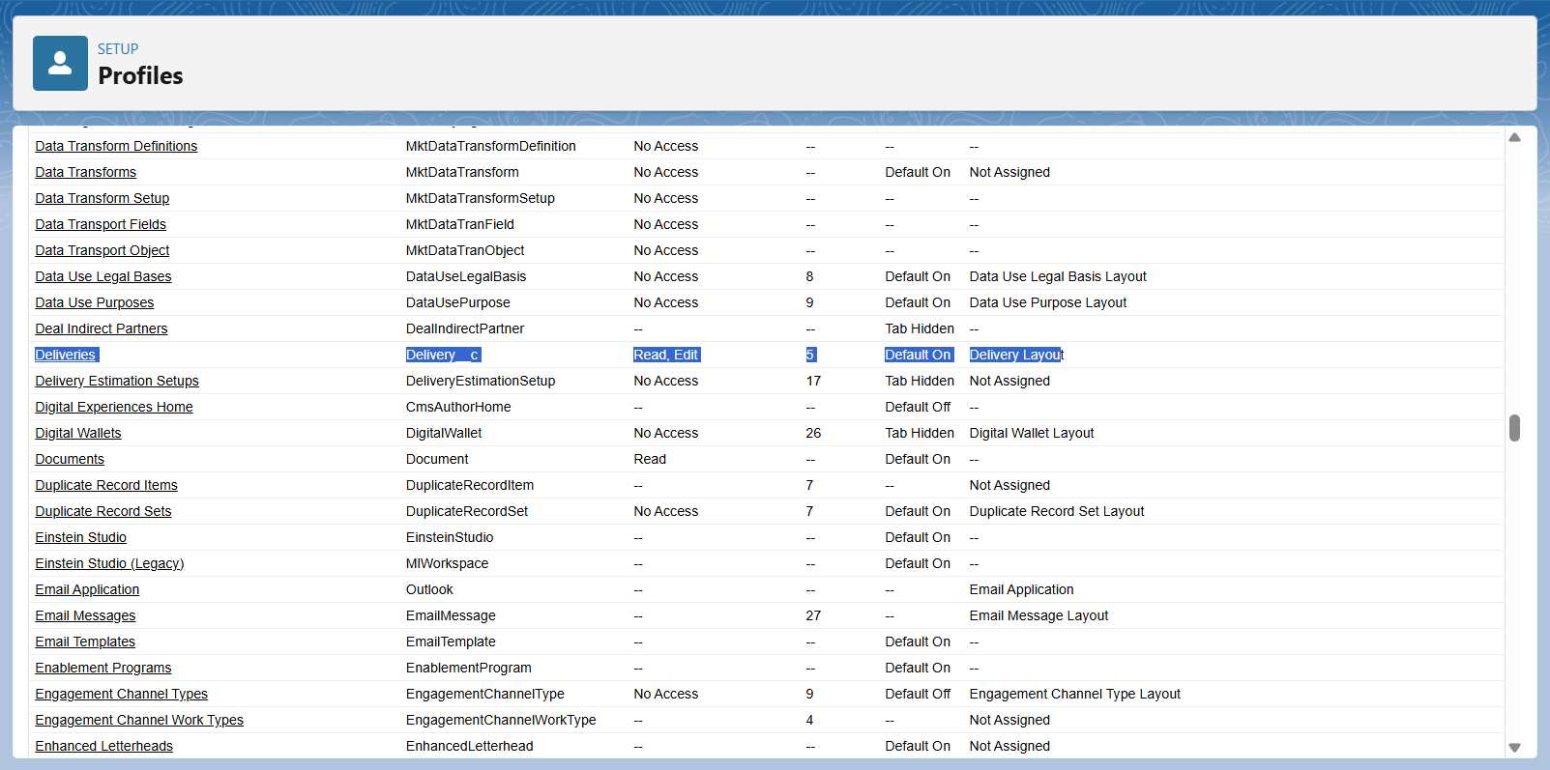

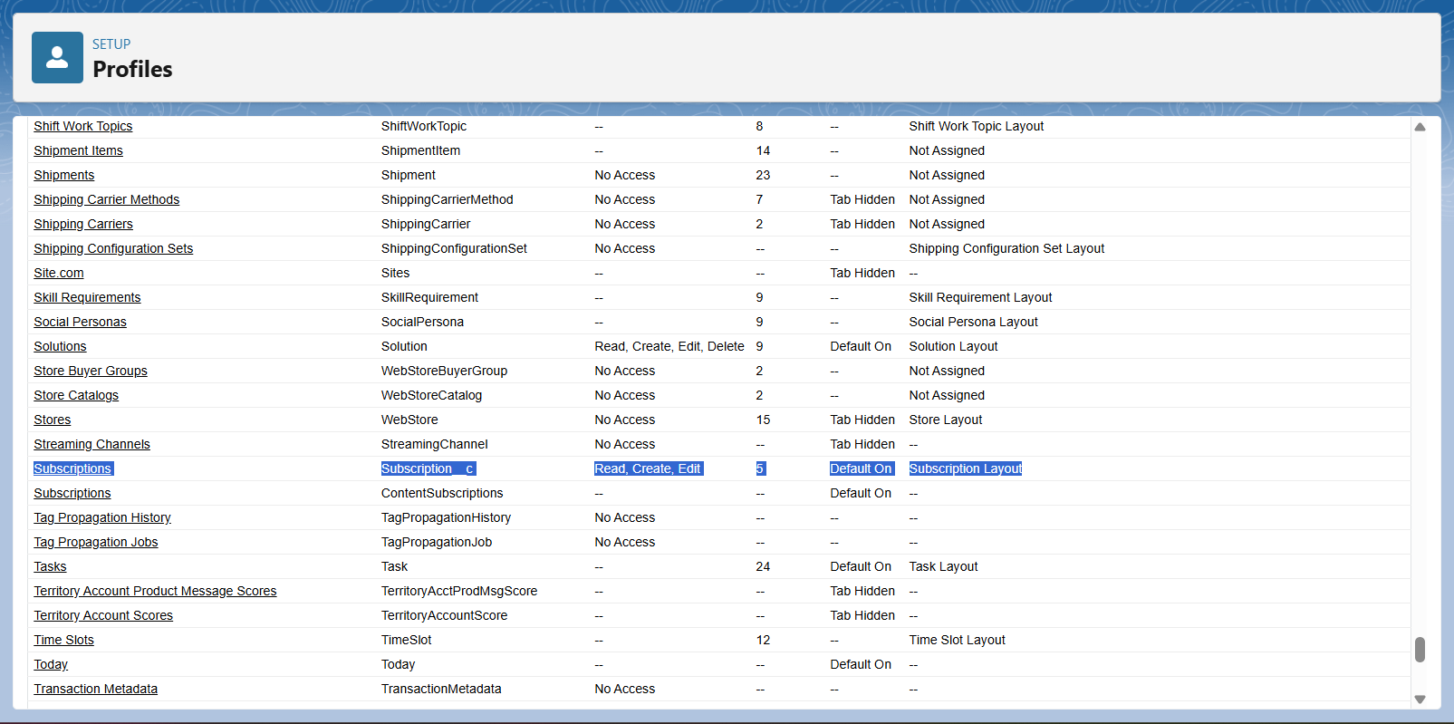

* Manager Profile:- Full access to all records, billing, and reporting.

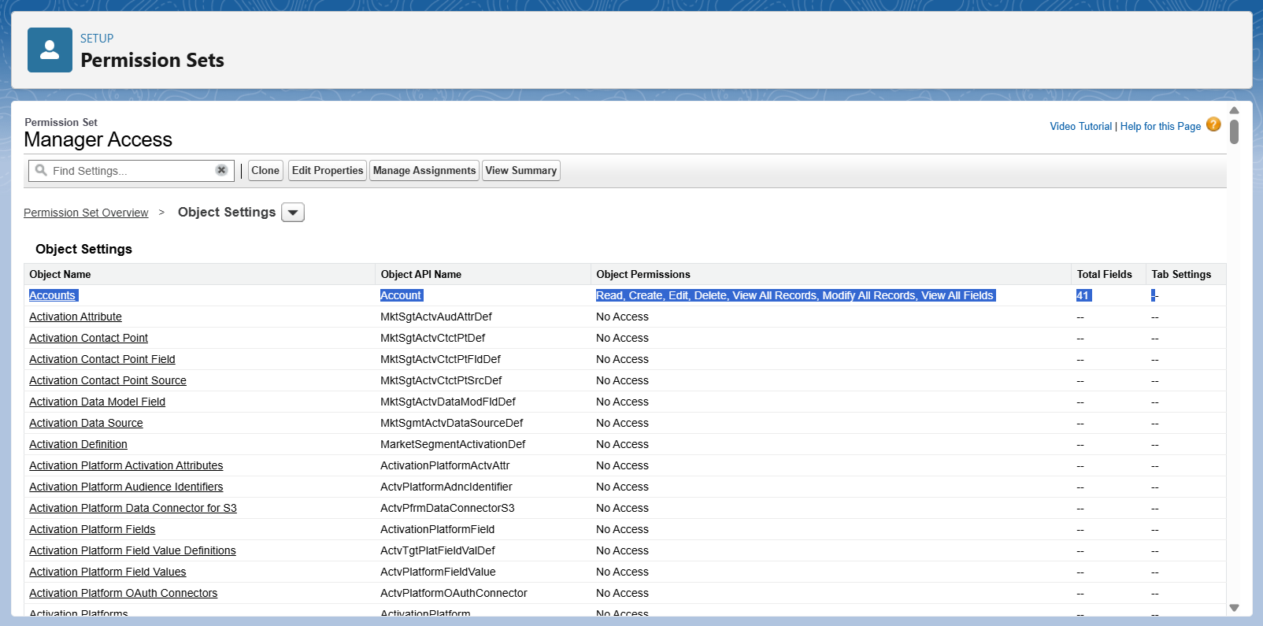

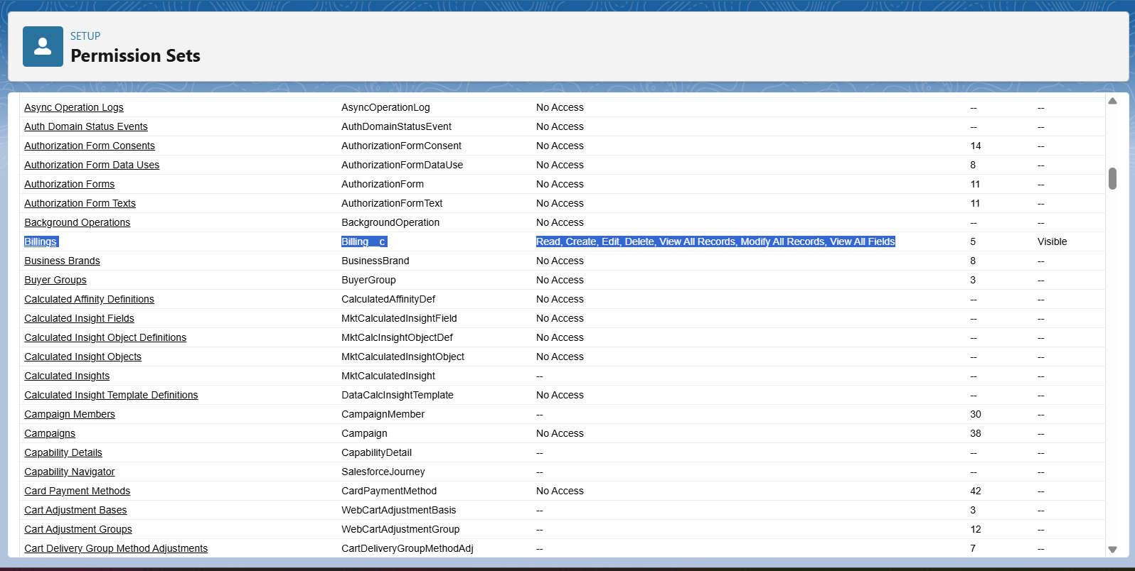

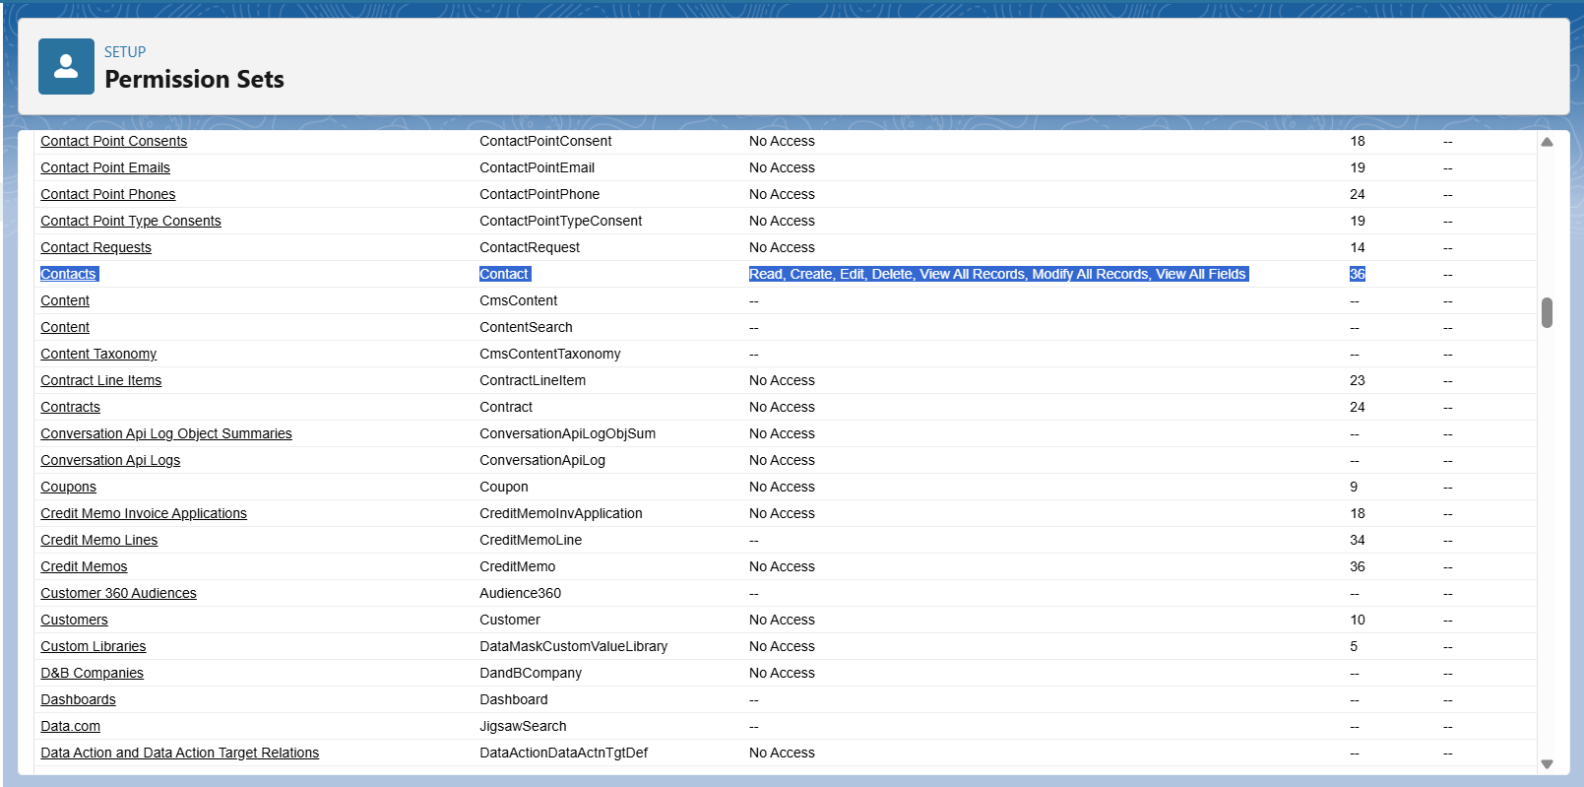

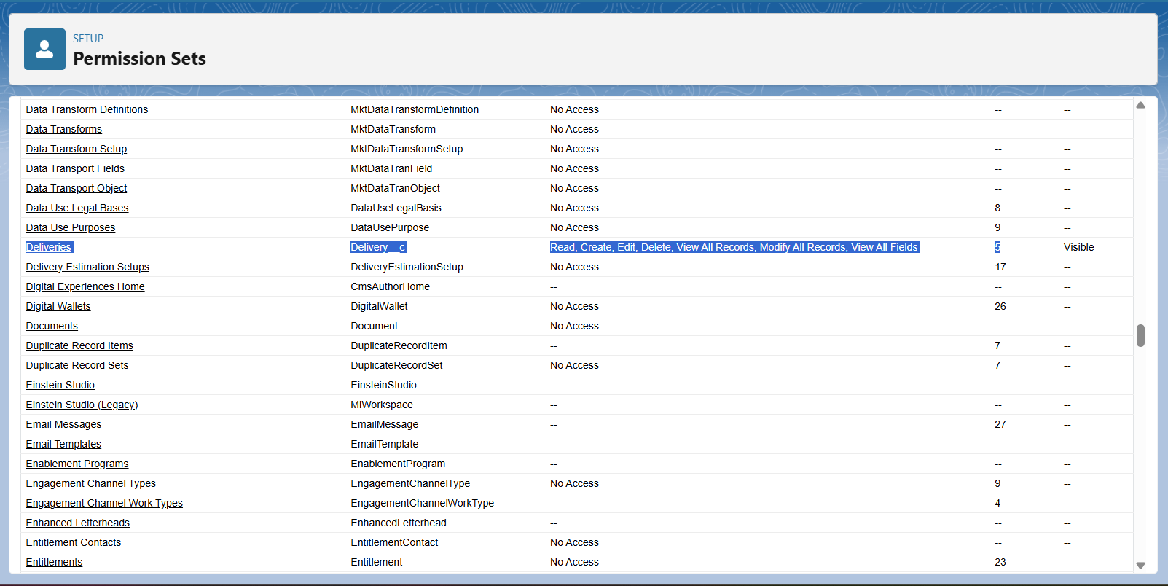

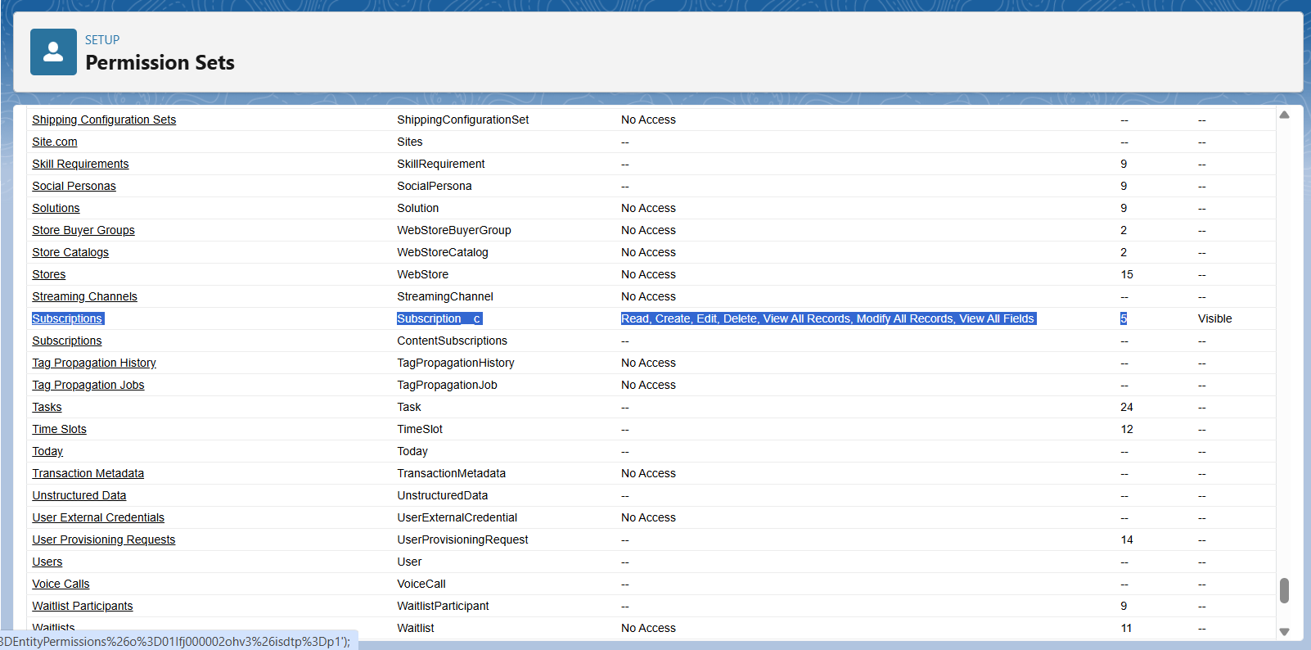

* Roles:-
* Manager (Top).
* Customer Support Executives (Middle).
* Delivery Agents (Bottom).
* Record visibility rolls up to Manager for tracking.

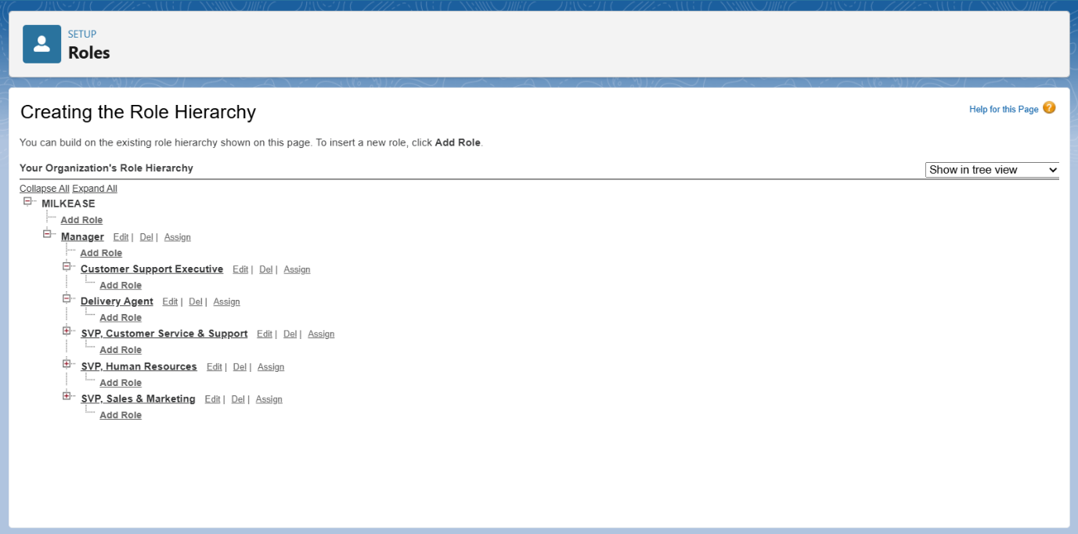

* Permission Sets:-
* Some permission set use when special access is needed.
* Report Access :-

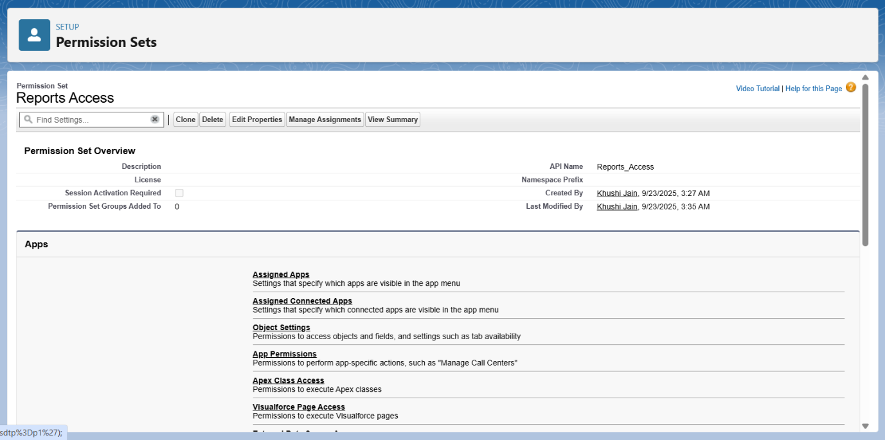

* Billing Access :-

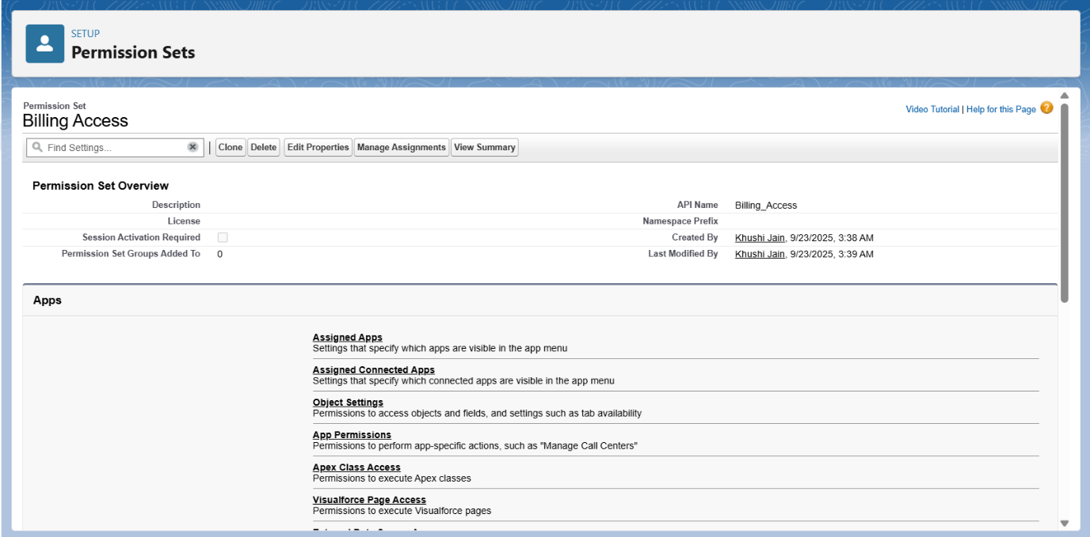

* Route Supervisor Access:-

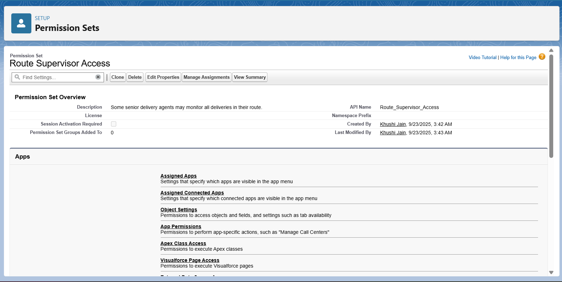

* Data Import Access :-

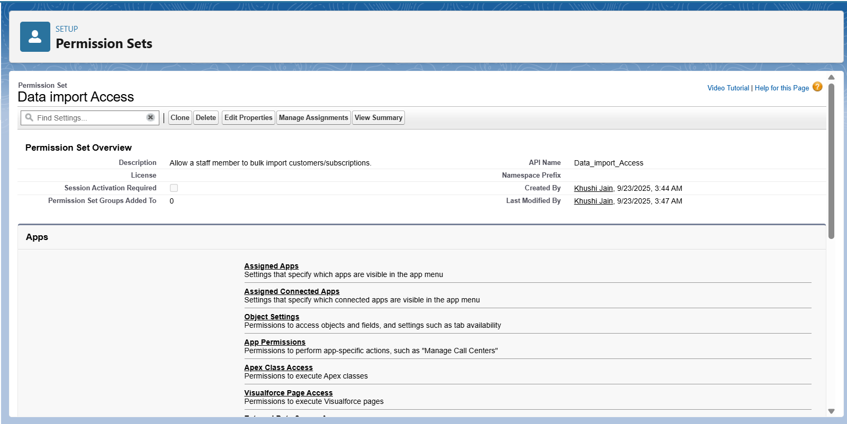

* OWD (Org-Wide Defaults) & Sharing Rules:-
* Customer Object → Public Read Only.

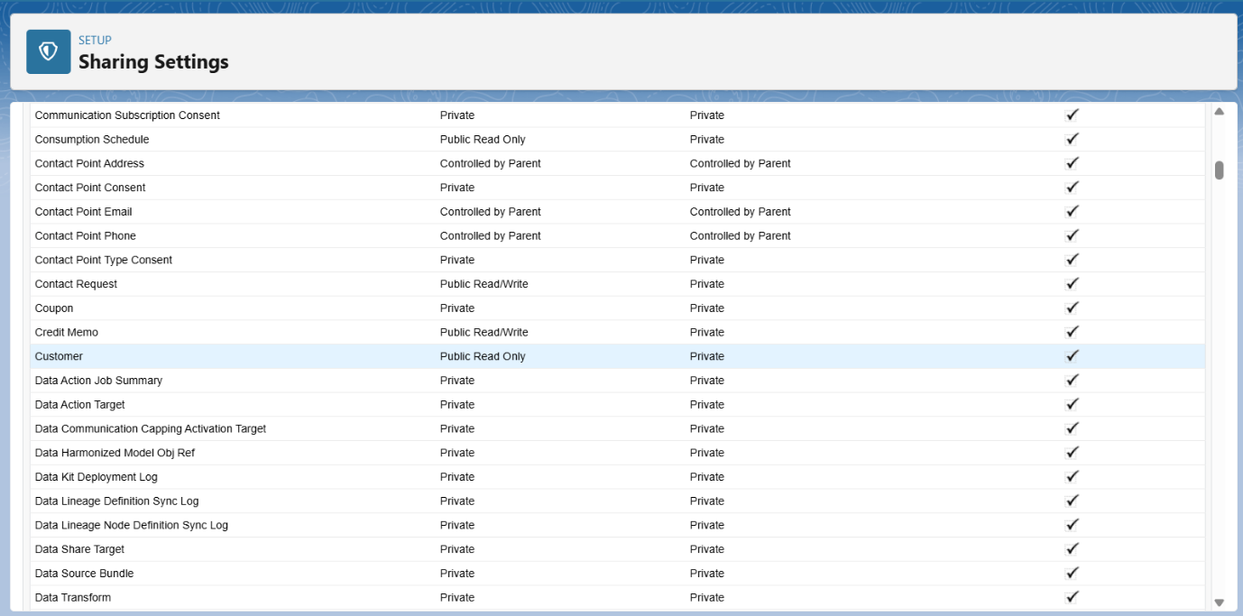

* Subscription → Private (only Owner & Manager see records).

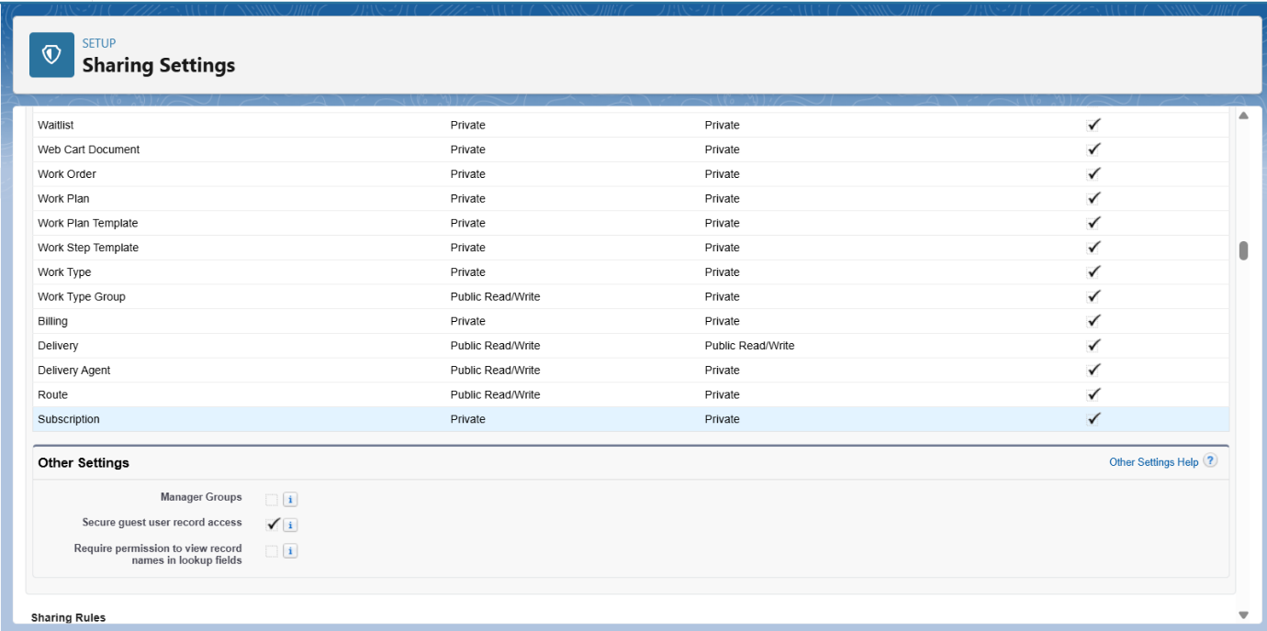

* Delivery Object → Public Read/write.

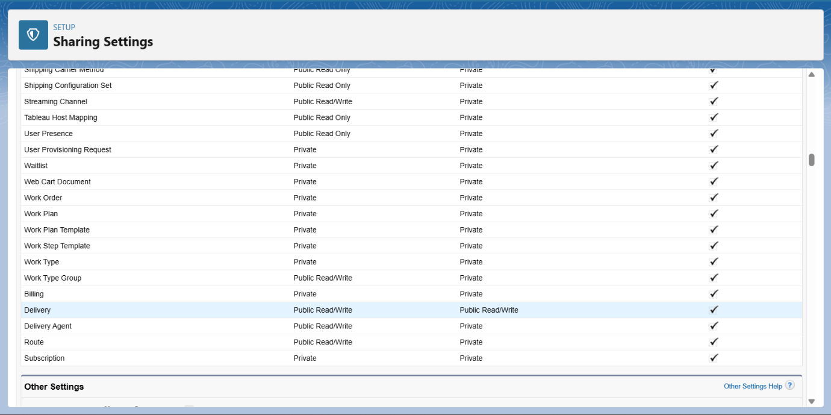

* Billing Object → Private for financial confidentiality.

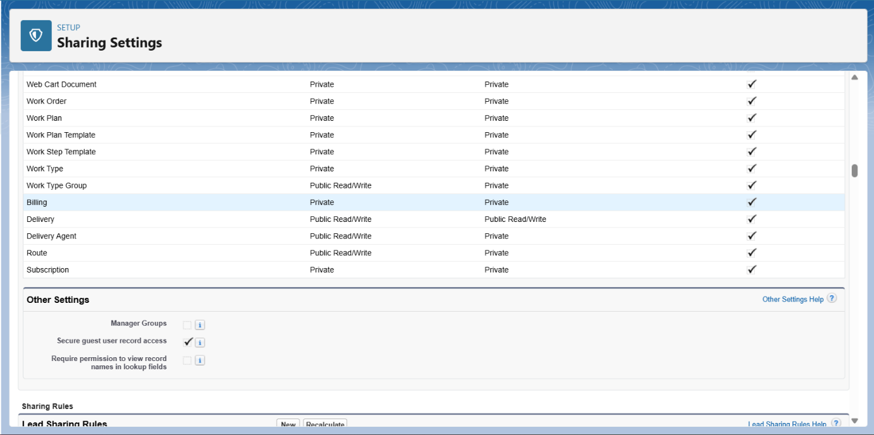

* Login Access Policies:-
* Restrict login hours (5:30AM–9:30PM for agents).

